#### Proposal for Internal Audit Services1

**Overview:**

<Write a brief overview about the company you are giving a proposal>

<Write a brief overview about the Industry Segment to which the client belongs>

<Write briefly about the general challenges faced by the Industry>

<Write briefly about how Internal Audit can help eliminate them>

<Write briefly about your organization’s capabilities in providing Internal Audit Services>

<Write briefly about the contents of this proposal>

**Scope and Objective:**

The objectives for the internal audit are as under:

* Evaluate the business processes to ensure that they are aligned to the business objectives.
* Evaluate the compliance to both the internal policies and procedures of the company and external regulations to the extent applicable to the following key processes.
* Evaluate the effectiveness and efficiency of the identified processes and related internal controls.
* Evaluate the accuracy of accounting information systems supporting the process.
* Evaluate progressively the risks relating to the business management covering information technology and general process

**Scope of work / Areas to be covered as part of Internal Audit:**

The scope shall be covering the transactions for the period <Month, Year> to <Month, Year>

***Management Process***

* Process 12
* Process 2

***Marketing***

* Process 1
* Process 2

1 Proposal may be printed on the letter head of the organization or a simple A4 Size Sheet.

2 You may also add a list of risks that shall be looked into in the process.

***Proposal for Internal Audit Services***

***Contract/Project Management***

* Process 1
* Process 2

***Client Relationship Management***

* Process 1
* Process 2

***HR Process***

* Process 1
* Process 2

***Finance and Accounts***

* Process 1
* Process 2

***Administration and Logistics***

* Process 1
* Process 2

***Information Technology***

* Process 1
* Process 2

The depth and sample size under the above business processes will be decided based on Risk assessment, where incase the Risk level is high, the area shall be analyzed in depth and the sample size shall also accordingly increase. The coverage shall be based on significant risks identified in the area of concentration. The methodology adopted for internal audit deliveries is separately given in this proposal.

**Methodology and Deliverables**3

We have structured methodology starts from mapping the corporate vision to audit deliveries and value-add. The following chart displays the steps generally followed by us in an Internal Audit Outsourcing Service.

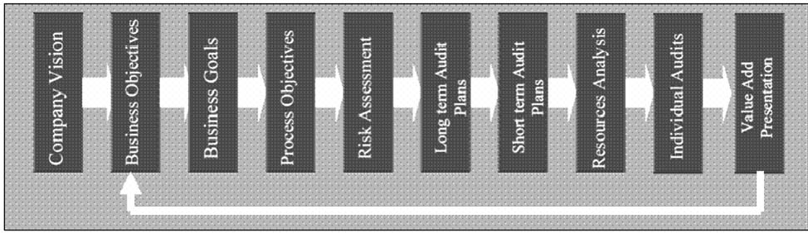

3 Each firm may have its own methodology / format of deliverables. This is model only.

***Proposal for Internal Audit Services***

The following are the benefits for the organization from outsourcing:

* Global best methodology for handling Internal Audits
* Relevant business / process / internal audit expertise and access to best practices
* Structured deliveries with performance indicators and terms of delivery
* Saving costs and efforts for the organization and help management concentrate on core competency

Our strong methodology also includes taking the input of the top management, process management and audit management to design a solution that means value addition. Our deliverable will give a road map to make the necessary process improvements that gives a big seat for practicality of implementation of recommendations.

***Pre Audit Opening***

* General Process Understanding
* Data Analysis and Summary Preparation
* Planning of Audit

***Detailed Walk Through***

* Detailed Walk Through
* Documentation of Walk Through Results

***Risks, Checklists, Audit Programme***

* Listing of Risks and Audit Programme (Checklists)
* Generation of Exceptions through Analytics
* Planning of Audit Programme Delivery
* Execution of Audit Programme
* Compilation of Observations and Draft Reporting
* Quality Check of adequacy of Evidences and Work Paper Linking
* Supervisory Review and Confirmation

***Report Compilation***

* Preparation of Audit Report
* Circulation of the Draft Report for Management Comments
* Collection of Management Comments

***Exit Meeting***

* Fixing of the Meeting Time
* Presentation and Action Plan Preparation
* Updation of the Action Plan into the Draft Report

***Proposal for Internal Audit Services***

***Report Issue***

* Final Official Report Issue as per Standards on Internal Audit (SIAs) Issued by the ICAI
* Audit Committee Presentation (Where Applicable)
* Audit Feedback Collection

***Each Audit Report shall contain the following information:***4

* Executive summary
* High, Medium, Low Risk Areas classified separately
* Detailed audit observations, covering Risks, Impact, Recommendations, Auditee Comments, Annexures of evidences
* Audit Implementation Action Plans with time lines and responsibility shall be updated after management discussion.
* Presentation to management and Audit Committee

The Audit shall be conducted as per the Standard on Internal Audit (SIA) 4 for Reporting released by ICAI.

Team, Schedule and Professional Fees:

Based on the Information provided to us with regard to the infrastructure and statistics, we estimate the following:

|  |  |  |  |
| --- | --- | --- | --- |
| **Sl No** | **Particulars / Name of the Resource**5 | **No of man**  **days / man months** | **Qualifications** |
| 1 | Partner |  |  |
| 2 | Senior Manager |  |  |
| 3 | Senior Associates / Consultants |  |  |
| 4 | Associates / Consultants |  |  |
| 5 | Junior Associates / Consultants |  |  |
|  | Total Time |  |  |

Taking the above deployments into account, the fee for the assignment is estimated as Rs. XXXXXXX/- excluding applicable service taxes. Incase there is any travel incidental to the delivery of the project we shall adhere to internal policies and shall be reimbursed on actual.6

4 Incase you would like to expand the deliverables, it can be done. Sometimes clients would like to know what is the format of deliverable, in such cases, an annexure may be added.

5 A detailed resource list may be given where necessary.

6 It is always good practice to add commentary about service tax and out of pocket expenses (OPEs) applicability / inclusion.

***Proposal for Internal Audit Services***

Resources Required

* An audit room will be set up having the sufficient no. of Table and chairs along with White board for meeting and discussion.
* Access to all the data, record, employees required for the effective performance of internal audit.
* Computers with access to company ERP, email and other systems with printing facility with adequate stationary.

Project Coordination:

We understand the importance of a project coordinator over the period of the assignment. The team shall be interacting with the process owners through the project coordinator.

About XYZ & Co

<Write about your organization, history, locations, its team members, no of man years of experience totally, specific points about your organization’s capabilities etc.,>

<Write a list of services your firm offers apart from internal audits>

<Give a list of clients and work experiences where applicable>7